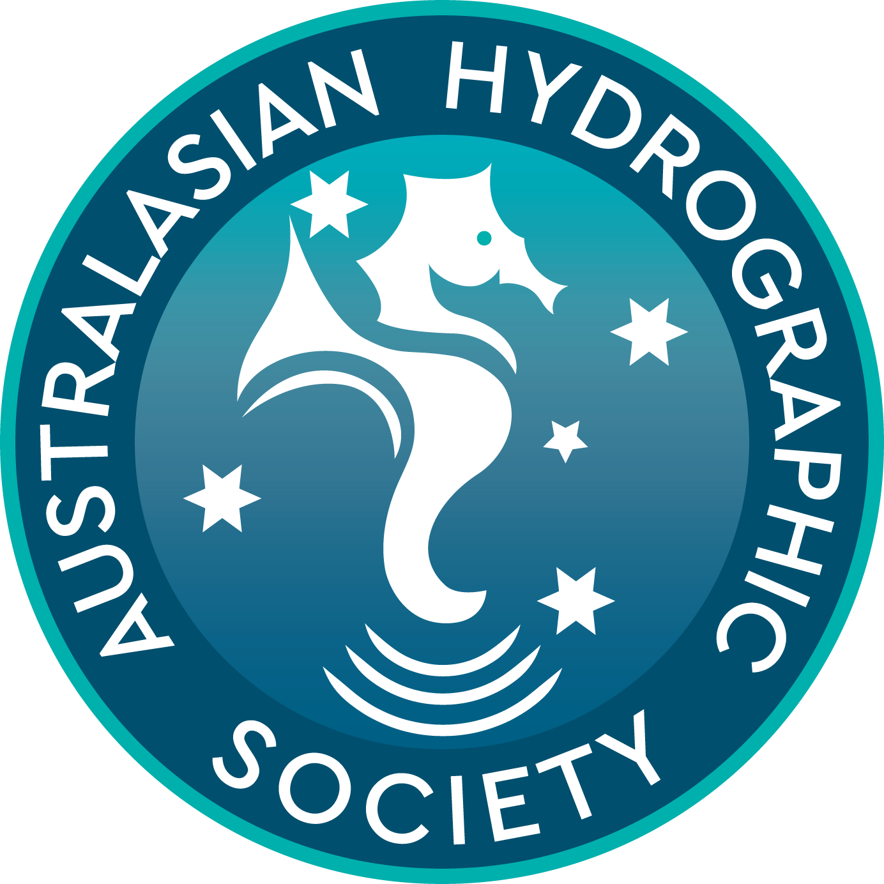

Australasian Hydrographic Society

15 January 2024

Distribution – All Members of the Australasian Hydrographic Society

POLICY DIRECTIVE (OBJECTIVE 4) – AHS Awards Scheme

Reference:
- Strategy and Business Plan – December 2001
- Concept Document – Establishment of an Awards Scheme – 7 Mar 2003
- Policy Directive (Objective 4) – AHS Awards Scheme - 30 Apr 2003
- AHS Awards Scheme Supplement, Extension to AOTM Projects & Activities - 15 Nov 2005

Purpose

1. The purpose of this Policy Directive is to outline the considerations and processes associated with the Awards Scheme for the Australasian Hydrographic Society (including the Australia on the Map Division (AOTM) projects and activities). The policy is endorsed by the AHS Council.

Background

2. The Society’s charter and constitution is to promote hydrography and related sciences. Increasingly, groups such as the AHS have sought to give recognition to those working in their area of interest as such recognition provides excellent visibility to the individuals and fosters strong individual and corporate involvement.

3. The AHS is by definition a learned organisation with a membership that covers a broad spectrum of all those involved or having an expressed interest in hydrography or related arts and sciences. As such, there is probably no better group involved in hydrographic pursuits to judge all of the various contributions across the industry and broader community.

4. In the past “tyranny of distance” made broader and equitable recognition administratively prohibitive. With the advent of better communications and analytical tools such limitations have now been substantially removed. Accordingly, a comprehensive awards scheme has been an accepted part of the Society’s strategic planning since December 2001, with the first awards being conferred in 2003. In 2006, Australia celebrated the 400th Anniversary of the first documented charting of the continent. This was a substantial opportunity to celebrate hydrography and for the AHS to recognise those who contribute to community understanding. Accordingly, the AHS Awards Scheme was extended to include individuals and groups who would not necessary qualify for consideration under previous guidelines. In particular, the Society is keen to recognise those efforts that encourage youth to embrace maritime exploration. Since inception the scheme has been very successful and acknowledged by the highest levels of government.

Policy - General

5. The general policy for the scheme aims to achieve a number of things:

- Firstly, it seeks to promote the values and ideals of the organisation. These are published at Reference A.

- Primarily, the scheme will give fair and equitable recognition to those individuals and organisations that have contributed to a field of endeavour.

- It will be inclusive of all elements of the maritime community but will be predominantly focused on financial AHS members and AOTM activities, which promote maritime exploration (hydrography). In a practical sense, this requires ensuring due process, but also encompasses considering the scope, exclusivity and number of awards. Selections will be avoided that are substantially based on popularity or proportion of media attention alone.

- For a relatively small and widespread group, the scheme will avoid unnecessary administrative or financial burden.

Scope

6. With these principals in mind, the scope of the awards scheme will be as follows:

- The AHS Award Scheme will seek to recognise those individuals, organisations, and companies that have by their actions contributed to promoting these values. Such recognition will be non-financial in nature.

- This scheme complements the mechanism for the award of a scholarship through the Education Award Scheme.

- The scheme and any modifications to it will be cognisant of not disenfranchising any particular element of the membership.

- Corporate sponsorship will be considered on a case-by-case basis for some awards, where such sponsorship will assist in promoting, conducting or awarding recognition. As such, recognition is non-financial in nature; this will be in terms of supporting awards nights (possibly during conferences, etc), administrative resources and the like. Additionally, as originally envisaged, this remains an incentive to encourage future Regions/Divisions to start up under the AHS (e.g., SE Asia).

- Each Region/Division (including the AOTM) will have equal representation for selecting Australasian awards. The scheme is designed to recognise that the Regions/Divisions, etc, have their own rights in the constitution, by virtue of the obligations of their selected Chairman / Director.

- The AHS Council as necessary will provide guidelines for the Regions/Divisions. In the event that a Region/Division has not been particularly active then “not awarded this year” would apply, rather than arbitrarily allowing recognition to be given.

- For reasons of greater credibility, some awards in the AHS scheme have never been exclusive to members only (e.g. for Literary Achievement, Media Achievement, etc). Nominations for any award, however, will only be accepted directly from a paid-up individual or corporate member of AHS or from a recognised member of the AOTM Division, or AOTM-associated committee.

- By encompassing the broader maritime community the Society seeks to grow the number of Australasian members, particularly from those individuals or organisations interested in maritime exploration, marine environmental sciences, etc.

Categories

7. The scheme encompasses the following categories. In all cases, the emphasis is on the nominator to present substantiating evidence.

a. Patron’s Gold Medal

The Society’s highest individual recognition, to be granted for the most significant service to industry and the Society, or technical and academic achievements in hydrography or related sciences, over an extended period. Awarded by the Society, only as occasion requires. This award is exclusive to members. Recipients will have reasonable travel expenses paid in order to attend the awards function where they will be awarded the Patron’s Gold Medal.

- Order of Merit (Service to the Australasian Hydrographic Society)

This is regarded as the Society’s second highest form of recognition (after the Patron’s Gold Medal) and is awarded for the promotion of values and excellence-in-support to the Australasian Hydrographic Society and its Regions/Divisions. Service Achievement is recognised separately for both individual and group work in the following sub-categories:

- Service Achievement (Operations) e.g. committee or symposium work
- Service Achievement (Administration) e.g. secretariat or co-ordination effort
- Service Achievement (Promotions) e.g. promotion of society activities
- Service Achievement (Logistics) e.g. for accounting, budgetary or legal support
- Service Achievement (Contribution) e.g. for the provision of resources

This award is restricted to members only. Nominations will only be considered from an individual or corporate member other than the nominee.

There is no time limit on how long an individual or corporation has been a member in order to be considered.

Particular consideration will be given to those who by their efforts have promoted the broadest inclusion of interested parties and the society’s charitable values.

- Award of Merit - Corporate Achievement

Awarded to private or public sector groups for excellence in the application of technology, the pursuit of innovation, management, history or dissemination of hydrography or related sciences. This will generally be considered for work over an extended period, but may be considered for highly notable achievement in a shorter period. The Society will grant separate awards in each sub-category for small business and major industry, in both private and public sectors:

- Achievement in Hydrography (e.g. group field work or rendering of surveys)
- Achievement in (related) Operations (e.g. port operations by a group)
- Achievement in (related) Support (e.g. policy, administration or training of hydrography)
- Achievement in (related) Engineering (e.g. system maintenance by a group)

Consideration for work undertaken outside the Australasian area will normally only be given to a financial AHS member.

- Award of Merit - Career Achievement

To be awarded to individuals for excellence in the application, history, dissemination or technological development of hydrography and related sciences. This will generally be considered for work over an extended period, but may be considered for highly notable achievement in a shorter period. The Society as a whole will grant separate awards in each sub-category for both private and public sector achievement:

- Achievement in Hydrography (e.g. field work or rendering surveys)
- Achievement in (related) Operations (e.g. maritime related operations)
- Achievement in (related) Support (e.g. administration or training of hydrography)
- Achievement in (related) Engineering (e.g. system maintenance or upkeep)

Consideration for work undertaken outside the Australasian area of interest will only be given to a financial AHS member.

- Award of Merit – Young Hydrographer of the Year

To be awarded to an individual (29 years old or younger) for excellence in the application, history, dissemination or technological development of hydrography. This will generally be considered for work over a minimum of 12 months. The Society will recognise work in the following sub-categories:

- Achievement in Hydrography (e.g. field work or rendering surveys)
- Achievement in (related) Operations (e.g. maritime related operations)
- Achievement in (related) Support (e.g. administration or training of hydrography)
- Achievement in (related) Engineering (e.g. system maintenance or upkeep)

Consideration for work undertaken outside the Australasian area of interest will only be given to a financial AHS member. The award can (at the discretion of the Awards Committee) be made to the same individual more than once.

- Award of Merit - Scientific and Technological Achievement

To be awarded for promoting the highest standards of accuracy and thoroughness in the application of hydrography, exploration and related sciences. The Society will recognise work in the following sub-categories:

- Scientific Achievement by an Individual (e.g., individual R & D)
- Scientific Achievement by a Group (e.g., departmental R &D)
- Technical Achievement by an Individual (e.g., application of existing technology)
- Technological Achievement by a Group (e.g., adaptation of existing technology)

Consideration for work undertaken outside the Australasian area or specific Region/Division will only be given to an individual financial AHS member or corporate financial AHS member based in the Australasian area. Where appropriate, group recognition will normally be given to a specific department or element within a corporate member.

- Award of Merit – Hydrographic Safety Achievement

To be awarded for promoting the highest degree of safety that can be achieved by (or for) the application of hydrography and related sciences. The Society will recognise work in the following sub-categories:

- Achievement in Hydrographic Safety by an Individual
- Achievement in Hydrographic Safety by a Group

Recognition is open to non-members, but a financial AHS individual or corporate AHS member must nominate them.

- Award of Merit - Environmental Achievement

To be awarded for excellence in the application of hydrographic or related systems towards the preservation of the environment. The Society will recognise work in the following sub-categories:

- Environmental Achievement by an Individual
- Environmental Achievement by a Group

Recognition will be particularly open to non-members, but a financial AHS individual or corporate AHS member or an AOTM Division Committee representative must nominate them.

- Award of Merit - Information Management Achievement

To be awarded for promoting the broadest correlation or dissemination of current or historical information between those engaged in hydrography and related sciences. The Society will recognise work in the following sub-categories:

- Information Management by an Individual
- Information Management by a Group

Consideration for work undertaken outside the Australasian area will normally only be given to a financial AHS member. Both the Regions/Divisions will recognise individual and group achievement.

- Award of Merit - Literary and Media Achievement

Literary Achievement: To be awarded for the best promotion of hydrography or related sciences through the publication of a book, papers or articles. The Society will recognise work in the following sub-categories:

- Literary Achievement (Non-Fiction)
- Literary Achievement (Fiction or Historical Adaptation)
- Literary Achievement (Professional Paper)
- Literary Achievement (Published Article)
- Literary Achievement (Other Media) (e.g. website article)
- Literary Achievement (by a Group or Publisher)

Media Achievement: To be awarded for the best promotion of hydrography or related sciences through the release of films, documentaries, websites or other media. The Society will recognise work in the following sub-categories:

- Media Achievement (Film)
- Media Achievement (Television)
- Media Achievement (Documentary)
- Media Achievement (Website)
- Media Achievement (Other Media) (e.g. radio or infomercial)
- Media Achievement (by a Group or Producer)

While wishing to avoid any analogy to other media awards, it may be appropriate, from time to time, to publish nominations by e-mail for some categories and seek a vote by the entire membership. Nominations will be considered by the Society as a whole for work produced outside Australasia, pending its relevance to the area. Awardees will normally be informed by letter (from the President) and presentation made separately to other awards. Notwithstanding, it may be appropriate from time to time to invite some awardees to regional or annual meetings to speak on their work and receive their award.

- Award of Merit - Exhibition Achievement

To be awarded to corporate and public entities for the best promotion of hydrography (excluding AHS Exhibitions) or related sciences through an exhibition or symposium display. The Society will recognise work in the following sub-categories:

- Exhibition Achievement by a Public Organisation (e.g. a maritime museum)
- Exhibition Achievement by a Major Industry
- Exhibition Achievement by a Small Business

Consideration will normally only be given to groups having operations in or from the Australasian area, with the possible exception being a display by a non-profit Public Organisation such as a school.

- Patron / President / Chairman’s Letters of Appreciation

To be awarded as the occasion requires, to both members and non-members for excellence-in-support to the Australasian Hydrographic Society, its Regions/Divisions. Sub-categories are as follows:

- Patron’s Letter of Appreciation (for exceptional support of the AHS)
- President’s Letter of Appreciation (for support of the AHS as a whole)
- Chairman’s Letter of Appreciation (for support to a Region/Division of the AHS)

These exist to allow recognition of support by individual or corporate members that would not otherwise be covered by an AHS Award. They also exist to provide formal recognition to individuals or groups (who do not hold membership), but who have provided support to the society. These will be at the discretion of the President or Regional / Divisional Chairmen respectively, cognisant that their use should be reasonably limited. This is particularly the case for members who, by virtue of their membership, are eligible for other forms of recognition or consideration within the scheme.

- Corporate Membership Certificate

A Corporate Member will be issued with a signed Certificate stating their membership and acknowledging their support to the AHS.

- Individual Membership Pin

An individual member accepted into the AHS will be provided with an AHS Individual Lapel Pin.

- Committee Member Pin

An individual member who serves in a Committee capacity in the AHS and its Regions/Division, including the AOTM, will be provided with an AHS Bronze Lapel Pin.

- Education Award Scheme

To be awarded under the existing statutes and requirements of the Society’s Constitution. This will remain the Society’s only financial form of recognition, and is administered under a separate AHS Policy document.

8. The selection criteria intentionally avoids being too prescriptive, on the basis of simplicity and allowing flexibility.

Nomination Process

9. Nominations are to be made using the standardised format in order to keep nominations succinct. A nomination form is attached to this document. Nominators are encouraged to provide supporting documentation and references (within reason). The forms are available on the appropriate websites. The content of all nominations will be private and confidential, with the exception that if successful, some information will be used for publicity purposes at the discretion of the AHS Council.

10. To avoid duplication, all nominations are to be forwarded to the Chairman of the Awards Panel of the AHS. The Chairman (or designate) will establish if they are eligible for Regional, Divisional or Society recognition in addition to checking the following:

- That the nomination form has been filled out appropriately
- That the nominee’s membership status is current, where required
- That the nomination is not duplicating other recognition
- The specific eligibility (rather than merit) of the nomination

11. Any doubts about the eligibility of a nomination are to be referred to the AHS Council. The Council will reserve the right to change the category of a nomination and advise the nominator accordingly; noting that Regions/Divisions are all represented on the Council.

Judging Process

12. The actual merit of Australasian nominations will be assessed by the AHS Awards Committee. The Awards Committee is made up of the Chairman of each Region/Division and a chairman appointed by the AHS Council.

13. To ensure due probity, The Chairman of the Awards Committee may invite one or more independent AHS members to the Awards Committee to aid in the judging processes i.e. members of academia. Such appointments will be on an annual basis, as required.

14. Where members of the Awards Committee are under consideration for an award themselves, and are aware of such consideration, they will be expected to exclude themselves from deliberating on that particular award. Further, if an Awards Committee member is nominated, then all considerations regarding the provision of an award are not to be divulged to that member before, during, or after the judging process.

15. In the event that the number of nominations becomes administratively prohibitive to process in a particular year, the Awards Committee has the right to defer consideration of a nomination to allow more time to consider it, or to allow more comparative nominations to be accumulated. Any uncertainties are to be referred to the AHS Council.

Selection Criteria

16. In assessing the merit of a nomination for an award, the Awards Committee will be expected to use the published values of the AHS as a guide. The Awards Committee will deliberate by email and while leaving the selection process up to the discretion of the Chairman and the Awards Committee, the President of the AHS will reserve the right to appoint an additional non-voting / non-deliberating member to assist in ensuring the actual process remains equitable. The President is not eligible for any award under the scheme. However, a member who has previously held the position of President is eligible. Any individual member of the Society may nominate a member of a committee or indeed the Awards Committee by forwarding the nomination directly to the President of the AHS where appropriate. These will be on-forwarded to the Awards Committee other than the nominee. Committee members so nominated would be expected to exclude themselves from any direct deliberation of an award for which they were nominated.

17. Once awardees have been decided by the Awards Committee and subsequently endorsed by the AHS Council, “the decision of the judges will be final”. Nominators are expected to acknowledge this when first submitting a nomination. All deliberations by the Awards Committee and the AHS Council will remain private and confidential. In the case where the Awards Committee are unavailable and for simplicity in deciding some awards, the Council reserves the right to nominate and approve an award directly.

18. As the AHS does not desire the “hype” associated with some award schemes, awardees will normally be advised in writing prior to presentation of an award. Unsuccessful nominations may be nominated in subsequent years.

19. While the selection process may seem complex, electronic communications and the fact the committees are fairly small and closely associated make the process relatively easy. The guiding principles for the scheme are that it be fair, equitable, and credible.

Awards Options

20. The AHS Awards options are as follows:

- Patron’s Gold Medal consisting of a gold medallion embossed with the AHS Crest and with the recipient’s name engraved on it. The awardee will also receive a Gold AHS Crest Lapel Pin and a framed Certificate.

- Order of Merit consisting of an engraved silver/alloy and wood plaque on wooden base with the recipient’s name engraved on it. The awardee will also receive a Silver AHS Crest Lapel Pin and a framed Certificate. An example of the certificate is attached to this document, refer Attachment 3.

- Award of Merit consisting of an engraved acrylic/glass plaque with the recipient’s name engraved on it and a framed Certificate. An example of the certificate is attached to this document, refer Attachment 2.

- “Letter” of Appreciation consisting of a framed AHS Certificate signed by the Patron, President or Regional Chairman. An example of the certificate is attached to this document, refer Attachment 3.

Corporate Membership Certificate consisting of a framed Certificate stating their membership and acknowledging their support to the AHS, refer Attachment 4.

Individual Membership Pin being a AHS Individual Lapel Pin.

Committee Member Pin being a AHS Bronze Lapel Pin.

Budget

21. The budget for the scheme will be determined by the AHS Council annually and published at the Annual General Meeting.
Operations and Schedule

22. Operation of the scheme will consist of the following actions annually:

End-Feb Advertise Awards to public (website, etc) and call for nominations
End-Apr Nominations Close (2 months after opening)
Start-May Awards Committee commences deliberations
Mid-May Awards finalised
End-May Awards produced/printed
End-May Majority of awardees formally advised
End June Awards presented at World Hydrography Day Celebrations/AGMs or similar.

23. Sufficient flexibility will be allowed so that for any unforeseen circumstances the Awards Committee and Council have the opportunity immediately prior to the AGM to finalise, amend, or reprint awards.

Summary

24. The awards scheme provides:

- A strong mechanism to promote hydrography and related sciences
- A strong means to promote the values of the Australasian society itself
- An excellent means to promote visibility and involvement in our industry
- Greater benefits to corporate membership
- Greater meaning to individual membership
- A substantial means to promote recruitment, particularly of corporate membership.

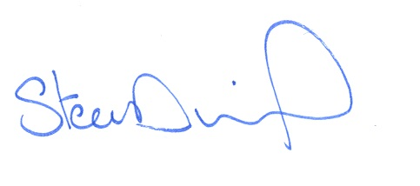

Steve Duffield
President
Australasian Hydrographic Society

Attachments:
- Nomination Form
- Award of Merit (example)
- Patrons “Letter” of Appreciation (example)
- Corporate Members Certificate (example)

Attachment 1 to AHS Policy
Dated: 15 December 2023

Australasian Hydrographic Society

Awards Scheme – Nomination Form

This form is to be used for nominating an individual or group to receive formal recognition under the AHS’s Awards Scheme. The categories, selection process and eligibility criteria are available by writing to the Honorary Secretary of the AHS, or from the society’s website. If you are uncertain as to the appropriate category, this field may be left blank. Fields marked with an asterisk (*) are compulsory for individual nominations. Fields marked with # are compulsory for group nominations.

Notes:
- Refer to POLICY DIRECTIVE (OBJECTIVE 4) – AHS AWARDS SCHEME, Nomination Process, paragraphs 10-12.

- Knowledge of the nominee by the Awards Committee cannot be assumed. The nomination must stand on its own merits and therefore must be comprehensive enough for the Committee to make a decision on the worthiness of the candidate. Consideration should be given to providing the contact details for an Independent Referee. Subject to the quality of the nomination the referee may or may not be contacted.

I / we would like to nominate

Title (or Group Name) #:

First Name *:

Middle Name:

Surname *:

Address:

Suburb:

State *#:

Postcode:

Country:

Telephone:

Email:

Nomination Category (if known, refer AHS Awards Scheme Policy Directive, Categories, Section 7):

In what roles or areas have the nominee excelled, include specific details such as list of achievements? (Please write 100 words or more)

What supporting documentation or references are attached?
For example, Biography, CV, Testimonials, etc.

Nominator’s Contact Information

Title (or Group Name) #:

First Name *#:

Surname *#:

Address:

Suburb:

State *#:

Postcode:

Country:

Telephone (work):

Telephone (home):

Email *#:

AHS Membership Number *#:

Referee Contact Information (optional)

Title (or Group Name) #:

First Name *#:

Surname*#:

Address:

Suburb:

State *#:

Postcode:

Country:

Telephone (work):

Telephone (home):

Email *#:

AHS Membership Number *#:

Acceptance Clause *#

I / we nominate the candidate listed above and agree to have my / our name published as the nominator in the event the candidate is successful, and for the information provided to be used by the Australasian Hydrographic Society for publicity purposes associated with the AHS Awards Scheme.

Name:

Signature:

Date:

Australasian Hydrographic Society

The Society’s Award of Merit for Corporate Achievement in Hydrography

HighTech Engineering Ltd, Project Team ANZAC

Including Ron Smith – Project Manager, Alec Smith – Chief Surveyor and five survey staff

For the successful completion of the 40,000,000 km2 Australia/New Zealand hydrographic survey in support of closer economic relations between the two nations.

Signed, this day, the XX of XX 20YY

Chair of Awards President Patron

